GROSVENOR CHAPEL PILGRIMAGE 2016
“The Spirit in Umbria: In the Footsteps of the Syrian Hermits,
St Benedict of Nursia & St Francis of Assisi” 6th to 11th October 2016
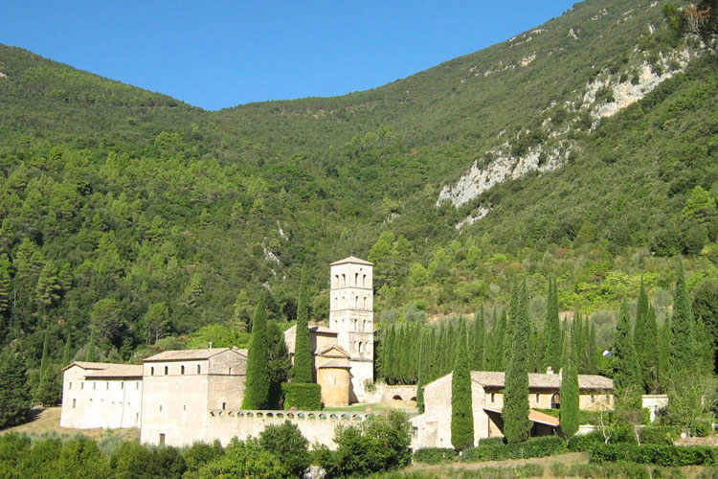
I am seeking an expression of interest in a Chapel Pilgrimage to some of the spiritual sites of Umbria in Italy, for five days from Thursday 6th until 11th October 2016.
The intention is that the Pilgrimage would have both a retreat component – the stability of staying in one place, at the stunning Abbey of San Pietro in Valle (sanpietroinvalle.com) and having quiet time to pray, as well as a pilgrimage element, visiting certain sacred sites.
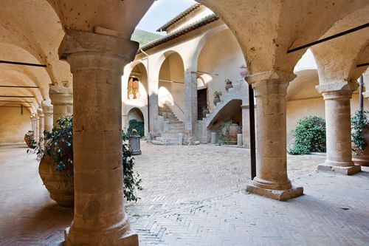

Our Destination
The Abbey of San Pietro in Valle was founded upon a Syrian Hermitage of the fifth century. The site also contains a wonderful church in which we would hold our services. The Abbey is now a very beautiful hotel, which nonetheless has not lost its monastic ambience, positioned as it is in a secluded, strategic and majestic valley pass in the south of Umbria.
From the Abbey we would visit some of the spiritual sites of the surrounding area. The rich spiritual history of Umbria weaves together the traditions of Syrian hermits (the 8th century cave-hermitage of "L'Eremo della Madonna della Stella."), St Benedict of Nursia (480 – 543/7AD) (the Basilica of San Benedetto, Norcia) and St Francis of Assisi (1181/2 – 1226AD) (Sacro Speco, nr. Narni). We would spend our final day in Assisi itself.
The Logistics
We would fly into Perugia Airport, close to Assisi, with Ryan Air, from Stansted Airport (c. £67.98).
Flights: Outward – 6th October London STN to Perugia 07.30 – 11.05
Return 11th October Perugia to London 11.30 – 13.00
Four nights at the Abbey with breakfast in a Standard Room, with the 15% group reduction we have negotiated, would cost £380.6 (£95.15 per night) for a shared room for two (i.e. £47.58 per person per night or £190.32 in total), or £301.84 (£75.46 per night) for a single. There are also other more expensive rooms and only a limited number of standard rooms.
We will also stay one night in Assisi, our accommodation is yet to be confirmed.
We would also hire eight-seater cars from Perugia airport, which would mean that each person would contribute around £50 and the cost of petrol would then be split at the end of the Pilgrimage.
In short, the estimated cost thus far in the planning of the Pilgrimage, excluding lunch and dinner and petrol and one night in Assisi, would £308.30 (this may vary depending on the type of room you decide to have at the hotel).
Our Companions on the Pilgrimage
Fr Thomas Kane, CSP preached at the Chapel last July. He is Associate Professor of Homiletics and Liturgical Practice at the Boston College School of Theology. He and I will lead the Pilgrimage, and Fr Thomas will also bring a small group of 7 people from the USA to join our Pilgrimage. You can read about Fr Thomas here: www.paulist.org/bio/father-thomas-kane-csp

BOOKING
Places on the Pilgrimage will be limited and distributed on a first come, first served basis.
To book your place you will need to fill in the “Booking Form” below and make a non-refundable deposit of £65 by cheque to “Grosvenor Chapel”, marking on the back of the cheque and the envelope “Grosvenor Chapel Pilgrimage”.
There will be an Initial Booking date of Sunday 20th March 2016.
People can still book after that date, but some prices may have changed.
YOU ARE RESPONSIBLE FOR BOOKING YOUR RETURN FLIGHT PERUGIA AIRPORT (AS ABOVE) AND YOUR JOURNEY TO AND FROM STANSTED AIRPORT.
Costs of flights will vary depending on when you purchase the ticket.
We are prepared to help those who struggle with making a booking via the internet, but in general we would prefer individuals to purchase their own ticket as the Chapel has no credit card purchase facility.
If you are in this situation please contact Fr Richard or Lis Hasted:
richard.fermer@grosvenorchapel.org.uk; lis.hasted@grosvenorchapel.org.uk

Booking Form
Grosvenor Chapel Pilgrimage “The Spirit in Umbria”
6th -11th October 2016

Full Name (as on the passport): ………………………………………………………
………………………………………………………

Your Passport Number: ………………………….
(For Hotel purposes)
Do you have any specific dietary requirements that the hotel should know about? ………………………………………………………………………………………………

Is it essential for you to have a ground floor room? Yes/No

What kind of room would you like to be in? Single/Double for a couple/ Shared with two individual beds.

Do you have any medical conditions which may affect your travel and about which it may be sensible for the Pilgrimage leaders to know?
……………………………………………………………………………………………………………………………………………………………………………………………………………………
Please enclose with this form a cheque for £65 payable to “Grosvenor Chapel”
Please send to:
The Pilgrimage Secretary
The Grosvenor Chapel
24 Sout Audley Street
London, W1K 2PA

