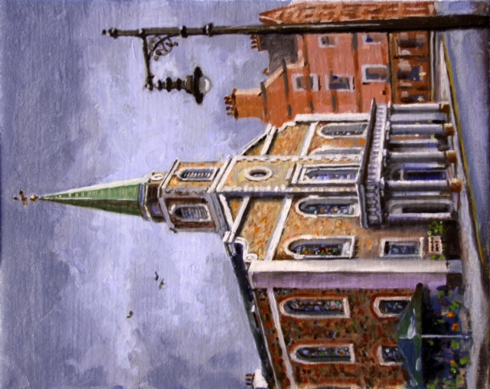

GROSVENOR CHAPEL

EVENTS AND SERVICES

SPRING 2017

Sunday 15th January ~ Renewal of Baptismal Vows 11.00 am

All who have been baptised at the Chapel are invited to join this service for a renewal of baptismal vows. Drinks will be served after the service (£2.00 donation).

Sunday 22nd January ~ Fr Dominic Robinson SJ from Farm Street Church will be preaching 11.00 am

The service will be followed by a simple lunch (£6.00) and a talk “Terror and Hope in 2017: the experience of Christians living in Iraq” informed by Fr Dominic’s recent visit to the Christian communities in Iraq. Please sign up at the back of the Chapel or contact the office if you would like to attend.

Tuesday 31st January ~ Hymns and Pimms 3.00 - 4.30 pm

For people living with dementia and those who care for them. Friendship, singing and refreshment. We have different stimulating themes for reminiscence every month. If any members of the congregation would like to participate with this, please see Lis Hasted.

Sunday 5th February ~ The Rev’d Neil Evans, Director of Ministry at the London Diocese, will be preaching 11.00 am

The service will be followed by a simple lunch (£6.00) and a talk by Fr Neil based on Christian discipleship in urban life today. There will be an opportunity to sign up to attend at the back of the Chapel or contact the office for further details.

Sunday 12th February ~ Renewal of Marriage Vows during the Sunday service 11.00 am

Couples who have been married at the Chapel are invited to come and join those in the congregation celebrating their married life together. Drinks will be served after the service (£2.00 donation).

Tuesday 28th February ~ Hymns and Pimms 3.00 - 4.30 pm

For people living with dementia and those who care for them. Friendship, singing and refreshment. We have different stimulating themes for reminiscence every month. If any members of the congregation would like to participate with this, please see Lis Hasted.

Wednesday 1st March ~ Ash Wednesday 7.00 pm

Sung Eucharist with ashing to mark the start of Lent.

Sunday 5th March ~ The Rev’d Richard Carter from St Martin-in- the-Fields will be preaching 11.00 am

The service will be followed by a simple lunch (£6.00) a talk by Fr Richard about ‘Finding Christ amongst the Refugees’. Please sign up at the back of the Chapel or contact the office if you would like to attend.

Sunday 26th March ~ Mothering Sunday 11.00 am

Mothering Sunday Sung Eucharist celebrated with the children of the Sunday Club.

The Lent Course

Takes place in conjunction with St John’s Hyde Park and St George’s Hanover Square on Wednesdays 8th, 15th and 29th March and Thursday 23rd March. The theme is “Hope after the Death of Liberalism? Thinking the future of a Post Liberal Society”. A light supper will be offered from 7.00 pm. Further details to follow.

Tuesday 28th March ~ Hymns and Pimms 3.00 - 4.30 pm

For people living with dementia and those who care for them. Friendship, singing and refreshment. We have different stimulating themes for reminiscence every month. If any members of the congregation would like to participate with this, please see Lis Hasted.

Thursday 30th March ~ St Raphael Mass and Coffee Morning

There will be a Guild of St Raphael Healing Mass at 10.15 am followed by a coffee morning in the Garden Room at 11.00 am.
Holy Week

Palm Sunday (9th April) 10.45 am Blessing and exchange of palms in Mount Street Gardens, followed by Procession and Sung Eucharist
Holy Wednesday (12th April) 6.30 pm Stations of the Cross jointly with Farm Street Church and St George’s Hanover Square followed by drinks
Maundy Thursday (13th April) 7.00 pm Solemn Mass of the Last Supper and Watch
Good Friday (14th April) 12.00 noon The Liturgy of our Lord’s Passion
Easter Sunday Dawn Mass (16th April) 5.30 am followed by breakfast
Easter Sunday Sung Eucharist with orchestra (16th April) 11.00 am

Tuesday 25th April ~ Hymns and Pimms 3.00 - 4.30 pm

For people living with dementia and those who care for them. Friendship, singing and refreshment. We have different stimulating themes for reminiscence every month. If any members of the congregation would like to participate with this, please see Lis Hasted.

Priest in Charge
The Rev’d Dr Richard Fermer (on sabbatical until 7th April)

Assistant Clergy
The Rev’d Dr Alan Piggot and The Rev’d Canon Alistair
Macdonald-Radcliff

Chapel Administrator (Monday and Friday)
Fiona Andrews
Email: info@grosvenorchapel.org.uk

Community and Events Officer (Tuesday, Wednesday and Thursday)
Lis Hasted
Email: Lis.Hasted@grosvenorchapel.org.uk

Grosvenor Chapel
24 South Audley Street, Mayfair, W1K 2PA
Tel: 020 7499 1684 Twitter @grosvenorchapel
www.grosvenorchapel.org.uk

